**Applied Data Science**

**Visualisation Assignment**

**NAME** : ADEYEMI ABODUNRIN

**DATA source**: [Data](https://fivethirtyeight.com/features/higher-rates-of-hate-crimes-are-tied-to-income-inequality/)

**Github link:** [github link](https://github.com/Yhermii/Applied-Data-Science-Visualization-1.git)

**Visualisation 1**: **Hate crime reported by Southern Poverty Law Center(SPLC) and Federal Bureau of Investigation (FBI) in United States Cities per 100 people.**

Fig1 : **lineplot**

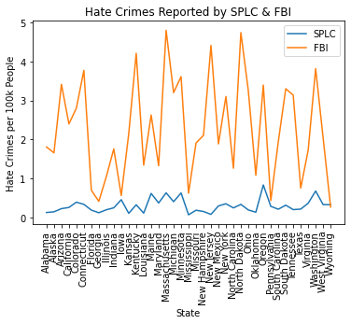

**Lineplot** is used here because it is used to compare values of various groups and show that which is most prevalent.

The Lineplot shows that the FBI reported higher hate crimes than the SPLC overall.

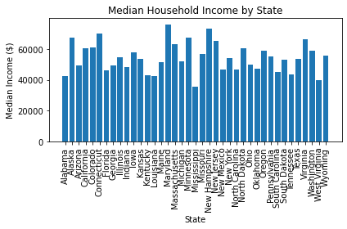

**Fig 2: Bar Plot**

**Visualization 2 :**  **Median Household Income by states**

**Barplot**: Bar plot is used to compare items between various groups .Furthermore, patterns and trends are easily recognised using barplot.

The barplot shows that the following states: Alaska, Connecticut, Maryland, Minnesota, New Hampshire,New Jersey and Virginia has a median income of more than Sixty Thousand United States Dollars(USD) $60,000.

**Fig 3: pie chart**

**Visualization 3 :**  **First 10 States reported by FBI**

**Piechart : piechart is used for categorized data,it shows percentages of a whole.**

The pie chart shows that amongst the first 10 states reported by FBI Connecticut has the highest percentage(19%) of hate crimes per 100k people. I.e 19,000 of 100,000 thousand people are involved in hates crimes in Connecticut.

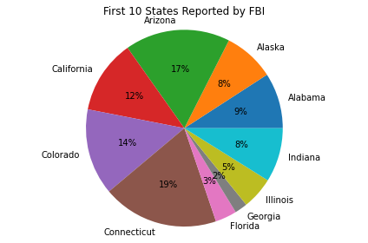

**In summary**, the plots enable visualization of the given data from different point of views- comparison of report rates between SPLC and FBI, Median income and hate crime distribution in the first 10 reported states by FBI.